

IIT Bombay–Groww INV.ENT Program
The IIT Bombay–Groww initiative aims to foster innovation, entrepreneurship, and research-led problem solving among students and faculty by creating an enabling ecosystem that bridges academic talent with real-world challenges. The project’s scope encompasses three key components the establishment of the Groww Innovation Space to provide dedicated infrastructure and collaborative facilities; the annual Innovation Grand Challenge to identify and support high-potential interdisciplinary ideas; and structured Proof-of-Concept (POC) support for student teams to translate classroom concepts into tangible prototypes. The approach focuses on phased implementation through transparent selection processes, mentorship-driven development, and outcome-based monitoring. Regular reviews, joint governance mechanisms, and data-driven progress tracking ensure alignment with both IIT Bombay’s innovation goals and Groww’s CSR vision of nurturing future-ready innovators.
What the program offers
Track A – Idea & Innovation Support: Enables early-stage teams to develop, test, and validate promising ideas through proof-of-concept funding and guidance.
Track B – Venture Development: Supports promising PoC’s with larger-scale funding, technical mentorship, expert guidance, and milestone-based support to advance towards market readiness.
Faculty & Expert Mentorship: Connects teams with IIT Bombay faculty and domain experts for technical guidance, project review, and milestone-based support.
Startup Clinic: Offers one-on-one expert mentoring on practical startup questions, from value proposition and company registration to IP protection, co-founder equity, and investor offers, with 42 teams having benefited so far.
Entrepreneurial Ecosystem: Creates pathways to mentorship, incubation, and the wider IIT Bombay innovation ecosystem.
Who can apply
All UG and PG students and researchers at IIT Bombay, from any discipline, in teams of 1-4 core members. Applications are open year-round.
Why it matters
The program builds a sustained innovation-to-venture pipeline at IIT Bombay, helping students move from ideas to experimentation, prototyping, validation and venture creation. The top 10–15% of Track A teams are expected to advance to Track B. Of Track B teams, 20–30% are expected to move into SINE incubation or raise external funding.
Impact & scale
- 420 teams to be supported over 4 years
- 60 teams selected so far: 53 in Track A and 7 in Track B
From ideas to impact
Ideas → Proof of Concept → Validation → Ventures → Impact
The IITB–Groww INV.ENT Program is more than a funding initiative. It is a long-term platform for building a culture of innovation and entrepreneurship at IIT Bombay.
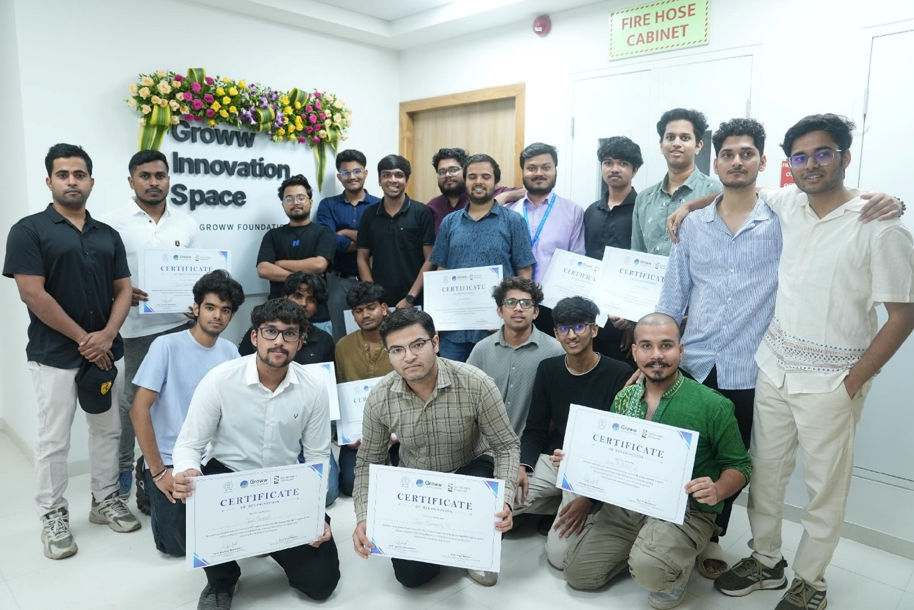

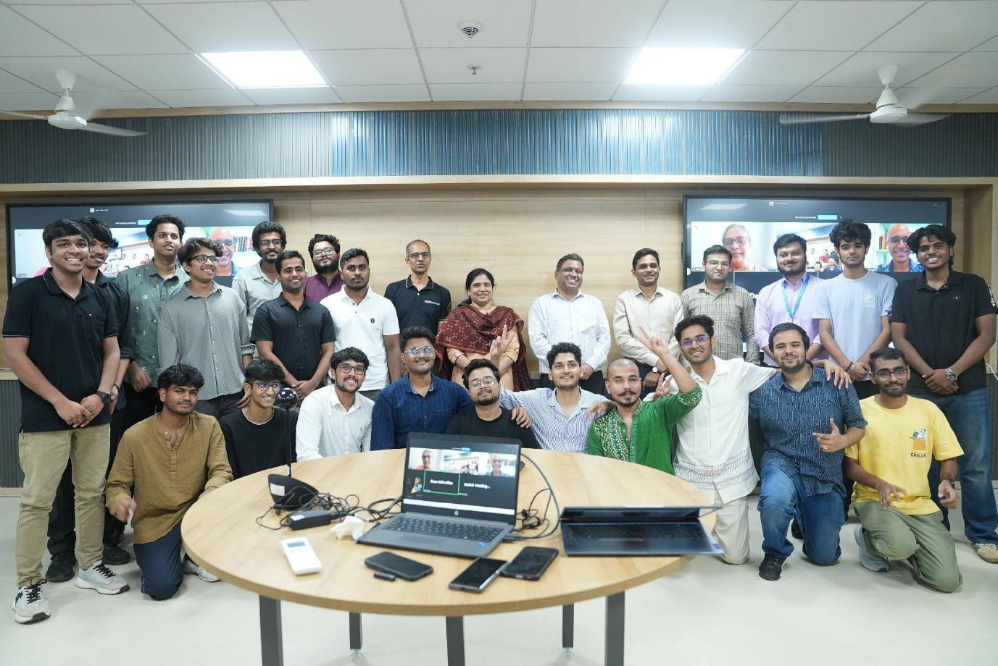

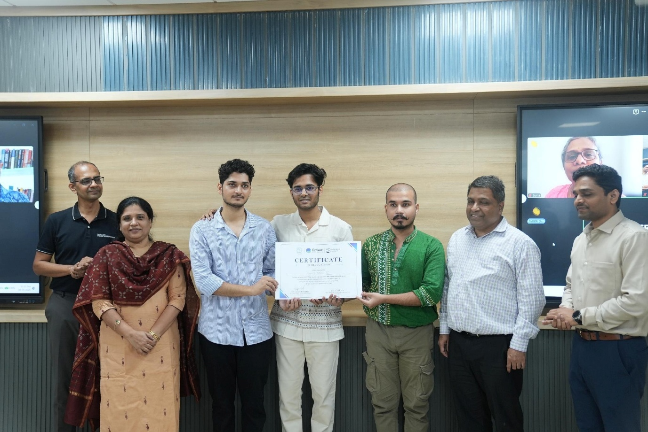

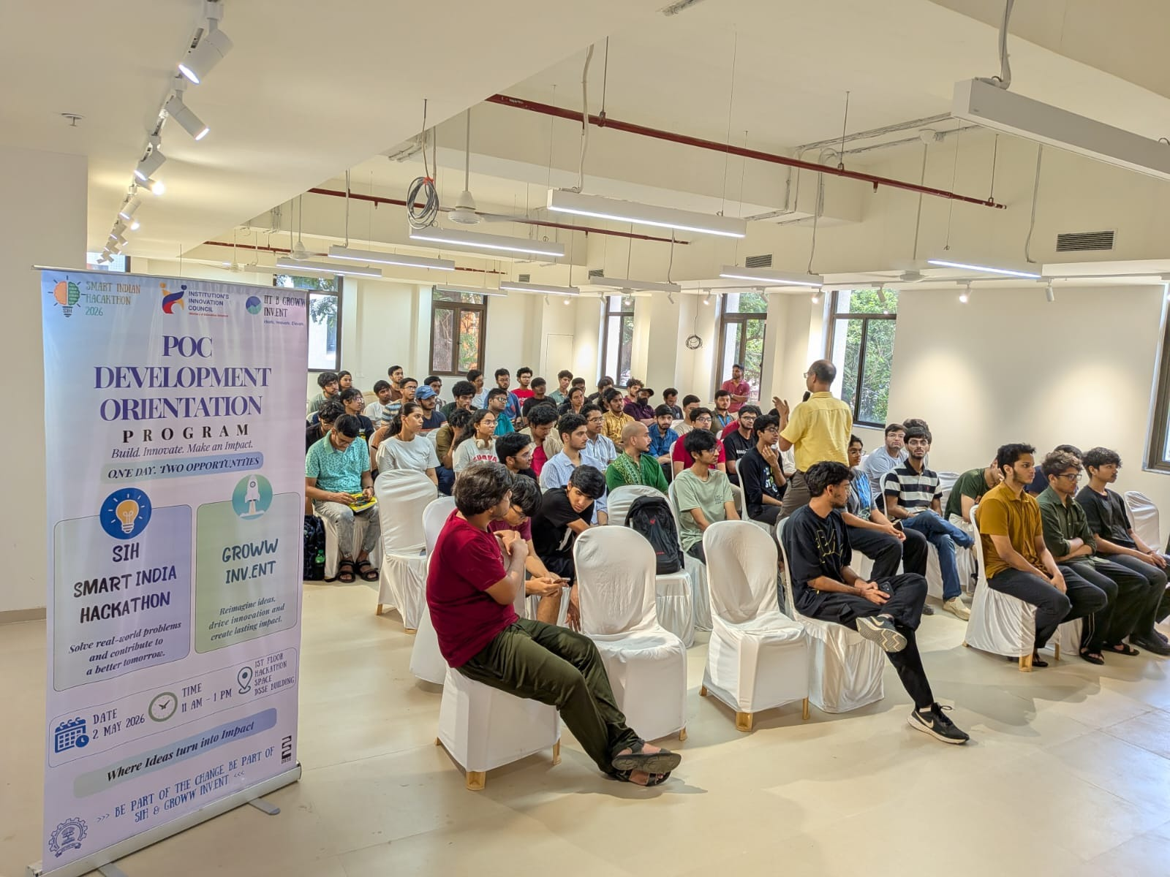

Website: https://www.growwfoundationiitb.org/
Contact no: 022 2159 6283

